PREORDER YOUR VALENTINE'S DAY GRAMS TODAY!

The HHCS Junior Class is taking orders for Valentine's Day grams. The grams will be delivered to students Friday, February 12th. Complete the student information and number of items ordered above each selection. Payment is due with order by cash or check. Make checks payable to HHCS. Orders are due by Monday,
February 8th, order early for best selection. Orders will be filled as received. Substitutions may be necessary.

(A) Valentine Conversation Heart Pop-Up (B) Valentine Stuffed Hedgehog (C) Valentine's Day Plush Cacti
$1.00 each $3.50 each $3.50 each
Number ordered _____ Number ordered _____ Number ordered _____
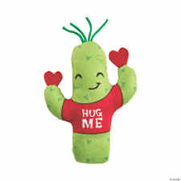

(D) Valentine Stuffed Pandas (E) Valentine Stuffed Dogs with Floppy Ears
$3.50 each $3.50 each
Number ordered _____ Number ordered _____

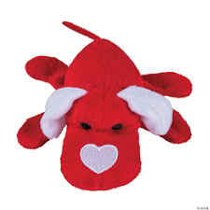

(F) Small bag of Valentine Candy
$2.00 each
Number ordered _____

Student Name__________________________________ Grade_________

Total amount paid $ ___________________

Please print the message you would like to send. ________________________________________________________________________________________________________________________

PLEASE FILL OUT ONE ORDER FORM FOR EACH STUDENT/PERSON

